Inductively Coupled Plasma-Mass Spectrometer (ICP-MS) with laser ablation system
The Laser Ablation-Inductively Coupled Plasma-Mass Spectrometer (LA-ICP-MS) Laboratory is equipped with a NWR-193 (Ar-F) Excimer laser ablation system and a PerkinElmer NexION 2000 ICP-MS. The LA-ICP-MS is suitable for in situ analysis of trace elements and isotopic ratios in solid materials. The 193 nm excimer laser is equipped with “infinitely variable aperture” system that allows to focus the laser in spots as small as 2 µm, ablating very small volumes of samples (a few µm³). A constant flow of He transport the ablated material towards the ICP-MS, where particles are first ionized by a plasma and then analyzed by a mass spectrometer.

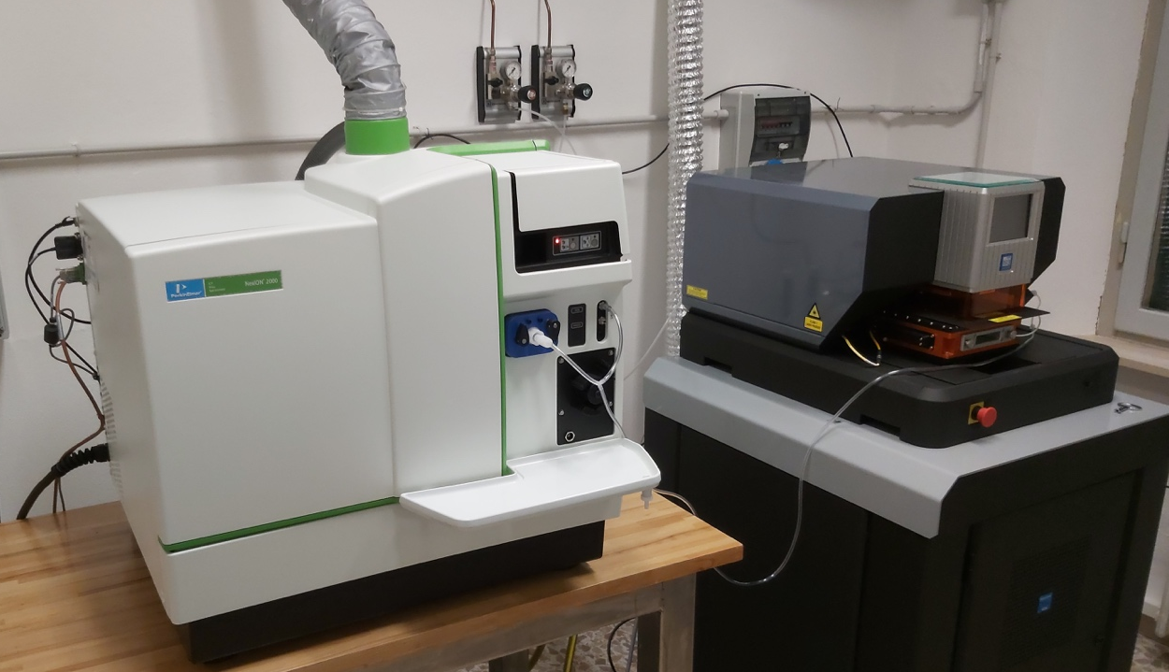

Applications
- Trace element analysis and isotopic ratios in inorganic materials
- U-Pb Geochronology
- Elemental mapping
- Depth profiling
- Bulk analysis

Materials
- Biological/plant materials
- Geological (minerals, glasses and mineral inclusions)
- Inorganic (ceramics, metals and alloys)

CISUP LA-ICP-MS Activity Report
Both the NWR-193 laser ablation system and the PerkinElmer NexION ICP-MS have been successfully installed in December 2020 at the Dipartimento di Scienze della Terra. The LA-ICP-MS system conditions are now being optimized for analysis of geologic materials.

